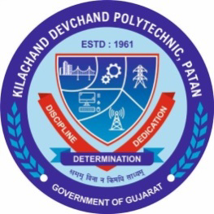

Student start-up research and innovation Cell

“SSIP 2.0 Outreach Student Sensitization Program”

Date
23/01/2023
Monday
11:00 AM to 12:00 AM

Program Report

K. D. Polytechnic, Patan

- DETAILS OF PROGRAM
Title of Program: | “SSIP 2.0 Outreach Sensitization Program”
Date: | MONDAY , 23/01/2023
Time: | 11:00 AM to 12:00 AM
Venue: | AB 104, NEW ACADEMIC BUILDING  K. D. Polytechnic, Patan.
Speaker: | R.J PRAJAPATI  Lecturer Electrical dept., KDP, Patan
Participant: | Students of 1st sem Electrical dept.

- Glimpse of program
